Chapter 8: MySQL Revision Tour
Lab Exercise(Solutions)
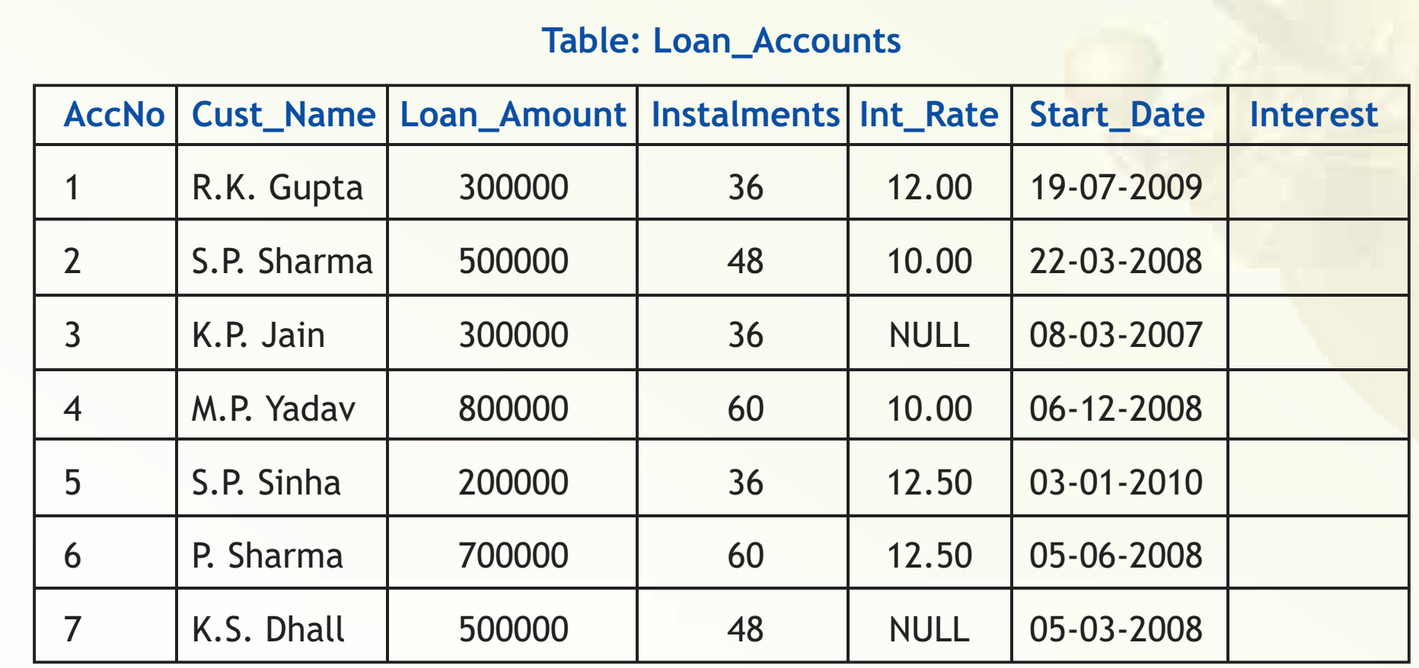
Consider a database LOANS with the following table:
Write SQL commands for the tasks 1 to 35 and write the output for the SQL commands 36 to 40:
Create Database and use it
1. Create the database LOANS.
Ans: create database LOANS;
2. Use the database LOANS.
Ans: use LOANS;
Create Table / Insert Into
3. Create the table Loan_Accounts and insert tuples in it.
Create table Loan_Account(AccNo int, Cust_Name varchar(30), Loan_Amount int, Instalments int, Int_Rate float, Start_Date Date, Interest);
Simple Select
4. Display the details of all the loans.
Ans: select * from Loan_Accounts;
5. Display the AccNo, Cust_Name, and Loan_Amount of all the loans.
Ans: select AccNo, Cust_Name, Loan_Amount from Loan_Accounts;
Conditional Select using Where Clause
6. Display the details of all the loans with less than 40 instalments.
Ans: select * from Loan_Accounts where Instalments < 40;
7. Display the AccNo and Loan_Amount of all the loans started before 01-04-2009.
Ans: select AccNo, Loan_Amount from Loan_Accounts where Start_Date < ‘2009-04-01’;
(MySQL uses date format as YYYY-MM-DD)
8. Display the Int_Rate of all the loans started after 01-04-2009.
Ans: select Int_Rate from Loan_Account where Start_Date > ‘2009-04-01’;
Using NULL
9. Display the details of all the loans whose rate of interest is NULL.
Ans: select * from Loan_Accounts where Int_Rate = NULL;
10. Display the details of all the loans whose rate of interest is not NULL.
Ans: Select * from Loan_Accounts where Int_Rate <> NULL;
Using DISTINCT Clause
11. Display the amounts of various loans from the table Loan_Accounts. A loan amount should appear only once.
Ans: Select Disting Loan_Amount from Loan_Accounts;
12. Display the number of instalments of various loans from the table Loan_Accounts. An instalment should appear only once.
Ans: Select Distinct Instalments from Loan_Accounts;
Using Logical Operators (NOT, AND, OR)
13. Display the details of all the loans started after 31-12-2008 for which the number of instalments are more than 36.
Ans: Select * from Loan_Accounts where Start_Date > ‘2008-12-31’ and Instalments > 36;
14. Display the Cust_Name and Loan_Amount for all the loans which do not have number of instalments 36.
Ans: Select Cust_Name, Loan_Amount from Loan_Accounts where Instalments <> 36;
15. Display the Cust_Name and Loan_Amount for all the loans for which the loan amount is less than 500000 or int_rate is more than 12.
Ans: Select Cust_Name, Loan_Amount from Loan_Accounts where Loan_Amount < 500000 or Int_Rate > 12;
16. Display the details of all the loans which started in the year 2009.
Ans: Select * from Loan_Accounts where Start_Date =’2009-01-01’;
17. Display the details of all the loans whose Loan_Amount is in the range 400000 to 500000.
Ans: Select * from Loan_Accounts where Loan_Amount >= 400000 and Loan_Amount <= 500000;
18. Display the details of all the loans whose rate of interest is in the range 11% to 12%.
Ans: Select * from Loan_Accounts where Int_Rate >= 11 and Int_Rate <= 12;
Using IN Operator
19. Display the Cust_Name and Loan_Amount for all the loans for which the number of instalments are 24, 36, or 48. (Using IN operator)
Ans: Select Cust_Name, Loan_Amount from Loan_Accounts where Instalments in (24, 36, 48);
Using BETWEEN Operator
20. Display the details of all the loans whose Loan_Amount is in the range 400000 to 500000. (Using BETWEEN operator)
Ans: Select * from Loan_Accounts where Loan_Amount Between 400000 and 500000;
21. Display the details of all the loans whose rate of interest is in the range 11% to 12%.
(Using BETWEEN operator)
Ans: Select * from Loan_Accounts where Int_Rate Between 11 and 12;
Using LIKE Operator
22. Display the AccNo, Cust_Name, and Loan_Amount for all the loans for which the Cust_Name ends with 'Sharma'.
Ans: Select AccNo, Cust_Name, Loan_Amount from Loan_Accounts where Cust_Name Like ‘%Sharma’;
23. Display the AccNo, Cust_Name, and Loan_Amount for all the loans for which the Cust_Name ends with 'a'.
Ans: Select AccNo, Cust_Name, Loan_Amount from Loan_Accounts where Cust_Name LIKE ‘%a’;
24. Display the AccNo, Cust_Name, and Loan_Amount for all the loans for which the Cust_Name contains 'a'
Ans: Select AccNo, Cust_Name, Loan_Amount from Loan_Accounts where Cust_Name LIKE ‘%a%’;
25. Display the AccNo, Cust_Name, and Loan_Amount for all the loans for which the Cust_Name does not contain 'P'.
Ans: Select AccNo, Cust_Name, Loan_Amount from Loan_Accounts where Cust_Name NOT LIKE ‘%P%’;
26. Display the AccNo, Cust_Name, and Loan_Amount for all the loans for which the Cust_Name contains 'a' as the second last character.
Ans: Select AccNo, Cust_Name, Loan_Amount from Loan_Accounts where Cust_Name LIKE ‘%a_’;
(Using ORDER BY clause)
27. Display the details of all the loans in the ascending order of their Loan_Amount.
Ans: Select * from Loan_Accounts order by Loan_Amount;
28. Display the details of all the loans in the descending order of their Start_Date.
Ans: Select * from Loan_Accounts order by Start_Date Desc;
29. Display the details of all the loans in the ascending order of their Loan_Amount and within Loan_Amount in the descending order of their Start_Date.
Ans: Select * from Loan_Accounts order by Loan_Amount;
Using UPDATE, DELETE, ALTER TABLE
30. Put the interest rate 11.50% for all the loans for which interest rate is NULL.
Ans: Update Loan_Accounts set Int_Rate=11.50 where Int_Rate=NULL;
31. Increase the interest rate by 0.5% for all the loans for which the loan amount is more than 400000.
Ans: Update Loan_Accounts set IntRate=Int_Rate + 0.5 where Loan_Amount > 400000;
32. For each loan replace Interest with (Loan_Amount*Int_Rate*Instalments)/(12*100).
Ans: Update Loan_Accounts set Interest=(Loan_Amount*Int_Rate*Installments)/(12*100);
33. Delete the records of all the loans whose start date is before 2007.
Ans: Delete from Loan_Accounts where Start_Date < ‘2007-01-01’;
34. Delete the records of all the loans of 'K.P. Jain'
Ans: Delete from Loan_Accounts where Cust_Name LIKE ‘K.P.Jain’;
35. Add another column Category of type CHAR(1) in the Loan table.
Ans: Alter table Loan_Accounts add column Category Char(1);
Find the Output of the following queries
36. SELECT cust_name, LENGTH(Cust_Name), LCASE(Cust_Name), UCASE(Cust_Name) FROM Loan_Accounts WHERE Int_Rate < 11.00;
Ans:
Cust_Name | Length(Cust_Name) | LCASE(Cust_Name) | UCASE(Cust_Name)
S.P. Sharma | 11 | s.p. sharma | S.P. SHARMA
M.P. Yadav | 10 | m.p. Yadav | M.P. YADAV
37. SELECT LEFT(Cust_Name, 3), Right(Cust_Name, 3), SUBSTR(Cust_Name, 1, 3) FROM Loan_Accounts WHERE Int_Rate > 10.00;
Ans:
LEFT(Cust_Name, 3) | Right(Cust_Name, 3) | SUBSTR(Cust_Name, 1, 3)
R.K | pta | .K.
S.P | nha | .P.
K.S | all | .S.

38. SELECT RIGHT(Cust_Name, 3), SUBSTR(Cust_Name, 5) FROM Loan_Accounts;
Ans:
pta Gupta
rma Sharma
ain Jain
dav Yadav
nha Sinha
rma harma
all Dhall
39. SELECT DAYNAME(Start_Date) FROM Loan_Accounts;
Ans:
Sunday
Saturday
Thursday
Saturday
Sunday
Thursday
Wednesday
40. SELECT ROUND(Int_Rate*110/100, 2) FROM Loan_Account WHERE Int_Rate > 10;
Ans: 13.20
13.75
13.75
Write the output produced by the following SQL commands:
41. SELECT POW(4,3), POW(3,4);
Ans: 64, 81
42. SELECT ROUND(543.5694,2), ROUND(543.5694), ROUND(543.5694,-1);
Ans: 543.57, 544, 540
43. SELECT TRUNCATE(543.5694,2), TRUNCATE(543.5694,-1);
Ans: 543.56, 540
44. SELECT LENGTH("Prof. M. L. Sharma");
Ans: 18
45. SELECT CONCAT("SHEIKH", " HAROON") "FULL NAME";
Ans: SHEIKH HAROON
46. SELECT YEAR(CURDATE()), MONTH(CURDATE()), DAY(CURDATE());
Ans: 2019, 08, 26
47. SELECT DAYOFYEAR(CURDATE()), DAYOFMONTH(CURDATE()), DAYNAME(CURDATE());
Ans: 2019, 2, Monday
48. SELECT LEFT("Unicode",3), RIGHT("Unicode",4);
Ans: Uni, code
49. SELECT INSTR("UNICODE","CO"), INSTR("UNICODE","CD");
Ans: 4, 0
50. SELECT MID("Informatics",3,4), SUBSTR("Practices",3);
Ans: form, actices

